What will we be learning?  Unit 8 – Organisation of sports events | Why this? Why now?  This unit is delivered in Year 13 in the Spring term after unit 3 has been completed. It is delivered during this time as the event can run at the end of the Spring term and weather is more suitable for an outdoor event. | Key Words:  Knockout tournament  League  Ladder  Round robin  Participative  Roles  Responsibilities  Feasibility  Contingency  Health and safety  Risk assessment  Policies  Procedures  Promotion  Review  Formative assessment  Summative assessment  Evaluation  Personal development plan
What will we learn?
- LO1 – Knowing different types of sports events and their purpose
- LO2 – Know the different roles & responsibilities involved in the planning & delivery of sports events
- LO3 – Be able to plan & promote a sports event
- LO4 – Be able to participate in the delivery of a sports event
- LO5 – Be able to review the planning & delivery of a sports event

What opportunities are there for wider study?
Careers/degree courses
- Sports science
- Physiotherapy
- PE teacher
Further reading:
Roles - Organising Sports Events Portfolio (weebly.com)
How Does a Round Robin Tournament Work? (reference.com)
6 Effective Strategies to Promote Your Sports Event - Billetto Blog
How will I be assessed?
- Teacher set assignments on Teams
CAM TECH – SPORT
UNIT 8

LO1 – KNOW DIFFERENT TYPES OF SPORTS EVENTS & THEIR PURPOSE
- Types of events: tournaments, participative, fundraising, coaching courses, outdoor and adventurous, sports camps
- Purpose of sports events: raising money, personal development, increasing participation, environmental, educational, formal competition

LO2 – KNOW THE DIFFERENT ROLES & RESPONSIBILITIES INVOLVED IN THE PLANNING & DELIVERY OF SPORTS EVENTS
- Roles:
  - Health & safety officer
  - Sports leader
  - Organiser
  - Finance officer
  - Marketing/media officer
  - Tutor/trainer/coach
  - Steward
  - First aider
  - Officials
  - Security
  - Caterer
- Responsibilities of each role.

LO3 – BE ABLE TO PLAN & PROMOTE A SPORTS EVENT
- Plan an event: purpose, activities, goals, feasibility, health and safety, facilities, policies and procedures, resources, contingency plan
- Promote an event:
  - Types of promotional material
  - Purpose of promotional material

LO4 – BE ABLE TO PARTICIPATE IN THE DELIVERY OF A SPORTS EVENT  - Delivery of an event:  - Carry out roles and responsibilities  - Effective use of resources & equipment  - Maintain health and safety  - Decision making and adaptations  - Managing participants effectively  - Communicate effective  - Respond appropriately to issues | 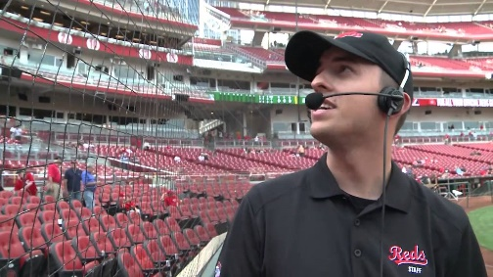
LO5 – BE ABLE TO REVIEW THE PLANNING AND DELIVERY OF A SPORTS EVENTS
- Review the planning & delivery of a sports event
- Methods to reviewing a sports event

